]
rWhat is an Object?

An object is a bundle of code that describes some sort of real-world object.

Physical objects: a car, which we can touch
Abstract objects: a specific route between two points, which exists as a well-defined entity, but has no physical element.

Car example:
Physical objects: car, factory, wheels, brake, engine
Abstract object: car manufacturer

Benefits of Object-Oriented Programming (OOP):
- Natural
- Efficient
- Simple
- Easy to change
- Reliable
- Comprehensible

Object Properties
Properties are the things that describe the object.

In the car example:
- Speed
- Color
- Is the engine running?
- Length
- License plate number
- Number of doors

Object Methods
The actions that an object can perform are called methods. For example:
- Change gear
- Steer right/left
- Accelerate
- Brake
- Start engine
- Stop engine

Encapsulation: the process of packaging up functionality in an object by specifying the essential characteristics and behaviors.

Building a Class
Defining Classes
The general form for defining a new class in PHP is as follows:

class myclass extends myparent {
public $var1;
public $var2 = "constant string";
public function myfunc ($arg1, $arg2) {
[..]
}
[..]
}

The form of the syntax is as described, in order, in the following list:

- The special form class, followed by the name of the class that you want to define.
- An optional extension clause, consisting of the word extends and then the name of the class that should be inherited from.
- A set of braces enclosing any number of variable declarations and function definitions. Variable declarations start with the special form public, private, or protected, which is followed by a conventional $ variable name; they may also have an initial assignment to a constant value. Function definitions look much like standalone PHP functions but are local to the class.

Accessing Member Variables

In general, the way to refer to a member variable from an object is to follow a variable containing the object with -> and then the name of the member. So if we had a variable $box containing an object instance of the class TextBox, we could retrieve its body_text variable with an expression like:

$text_of_box = $box->body_text;

SuperHTMLDef.php:
<?php

class SuperHTML{

//properties
var $title;
var $thePage;

function __construct($tTitle = "Super HTML"){
//constructor
$this->setTitle($tTitle);
} // end constructor

function getTitle(){
return $this->title;
} // end getTitle

function setTitle($tTitle){
$this->title = $tTitle;
} // end setTitle

function getPage(){

return $this->thePage;
} // end getPage

function addText($content){
//given any text (including HTML markup)
//adds the text to the page
$this->thePage .= $content;
$this->thePage .= "\n";
} // end addText

function gAddText($content){
//given any text (including HTML markup)
//returns the text
$temp= $content;
$temp .= "\n";
return $temp;
} // end addText

function buildTop(){
$cssFile = str_replace(" ", "_", $this->title);
$temp = <<<HERE
<!DOCTYPE html PUBLIC "-//W3C//DTD XHTML 1.0 Strict//EN"
"http://www.w3.org/TR/xhtml1/DTD/xhtml1-strict.dtd">

<html lang="EN" dir="ltr" xmlns="http://www.w3.org/1999/xhtml">
<head>
<meta http-equiv="content-type" content="text/xml; charset=utf-8" />
<title>$this->title</title>

</head>
<body>
<h1>$this->title</h1>

HERE;
$this->addText($temp);
} // end buildTop;
function buildBottom(){
//builds the bottom of a generic web page
$temp = <<<HERE
</body>
</html>

HERE;
$this->addText($temp);
} // end buildBottom;
//general tag function
function tag($tagName, $contents){
//given any tag, surrounds contents with tag
//improve so tag can have attributes
$this->addText($this->gTag($tagName, $contents));
} // end tag

function gTag($tagName, $contents){
//given any tag, surrounds contents with tag
//improve so tag can have attributes
//returns tag but does not add it to page
$temp = "<$tagName>\n";
$temp .= " " . $contents . "\n";
$temp .= "</$tagName>\n";
return $temp;
} // end tag

//header functions
function h1($stuff){
$this->tag("h1", $stuff);
} // end h1

function h2($stuff){
$this->tag("h2", $stuff);
} // end h2

function h3($stuff){
$this->tag("h3", $stuff);
} // end h3

function h4($stuff){
$this->tag("h4", $stuff);

} // end h4

function h5($stuff){
$this->tag("h5", $stuff);
} // end h5

function h6($stuff){
$this->tag("h6", $stuff);
} // end h6

function gBuildList($theArray, $type = "ul"){
//given an array of values, builds a list based on that array
$temp= "<$type> \n";
foreach ($theArray as $value){
$temp .= " <li>$value</li> \n";
} // end foreach
//shorten type if it included style information
$type = substr($type, 0, 2);
$temp .= "</$type> \n";
return $temp;
} // end gBuildList

function buildList($theArray, $type = "ul"){
$temp = $this->gBuildList($theArray, $type);

$this->addText($temp);
} // end buildList

function gDl ($listVals){
//Create a definition list from an associative array
$temp = "";
$temp .= "<dl>\n";
foreach ($listVals as $term => $def){
$temp .= " <dt>$term</dt> \n";
$temp .= " <dd>$def</dd> \n";
} // end foreach
$temp .= "</dl> \n";
return $temp;
}

function dl($listVals){
$this->addText($this->gDl($listVals));
} // end dl

function gBuildTable($theArray){
//given a 2D array, builds an HTML table based on that array
$table = "<table> \n";
foreach ($theArray as $row){

$table .= "<tr> \n";
foreach ($row as $cell){
$table .= " <td>$cell</td> \n";
} // end foreach
$table .= "</tr> \n";
} // end foreach
$table .= "</table> \n";

return $table;
} // end gBuildTable

function buildTable($theArray){
$temp = $this->gBuildTable($theArray);
$this->addText($temp);
} // end buildTable

function startTable(){
$this->thePage .= "<table>\n";
} // end startTable

function tRow ($rowData, $rowType = "td"){
//expects an array in rowdata, prints a row of th values
$this->thePage .= "<tr> \n";
foreach ($rowData as $cell){
$this->thePage .= " <$rowType>$cell</$rowType> \n";
} // end foreach
$this->thePage .= "</tr> \n";
} // end tRow

function endTable(){

$this->thePage .= "</table> \n";
} // end endTable

function startForm($action = "", $method = "post"){
//begins form creation with fieldset
$temp = <<<HERE
<form action = "$action"
method = "$method">
<fieldset>

HERE;
$this->thePage .= $temp;
} // end startForm

function endForm(){
//adds form end tag
$this->thePage .= <<<HERE
</fieldset>
</form>

HERE;

}// end endForm
function label($value) {
$this->tag("label", $value);
} // end label

function gTextbox($name, $value = ""){
// returns but does not print
// an input type = text element
// used if you want to place form elements in a table
$temp = <<<HERE
<input type = "text"
name = "$name"
value = "$value" />

HERE;

return $temp;
} // end textBox

function textbox($name, $value = ""){
$this->addText($this->gTextbox($name, $value));
} // end textBox

function gSubmit($value = "Submit Query"){
// returns but does not print
// an input type = submit element
// used if you want to place form elements in a table
$temp = <<<HERE
<button type = "submit">
$value
</button>

HERE;

return $temp;
} // end submit

function submit($value = "Submit Query"){
$this->addText($this->gSubmit($value));
} // end submit
function gSelect($name, $listVals){
//given an associative array,
//prints an HTML select object
//Each element has the appropriate
//value and displays the associated name
$temp = "";
$temp .= "<select name = \"$name\" >\n";
foreach ($listVals as $val => $desc){
$temp .= " <option value = \"$val\">$desc</option> \n";
} // end foreach
$temp .= "</select> \n";

return $temp;

} // end gSelect

function select($name, $listVals){
$this->addText($this->gSelect($name, $listVals));
} // end select
function formResults(){
//returns the names and values of all form elements
//in an HTML definition list
if (!empty($_REQUEST)){
$this->dl($_REQUEST);
} // end isset
} // end formResults

} //end of class
?>

Building a Simple Document with SuperHTML
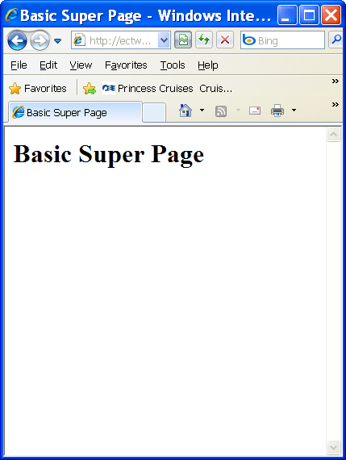 | Basics/BasicSuper.php  <?php  include "SuperHTMLDef.php";  $s = new SuperHTML("Basic Super Page");  $s->buildTop();  $s->buildBottom();  print $s->getPage();  ?>

Adding Text and Tags with SuperHTML
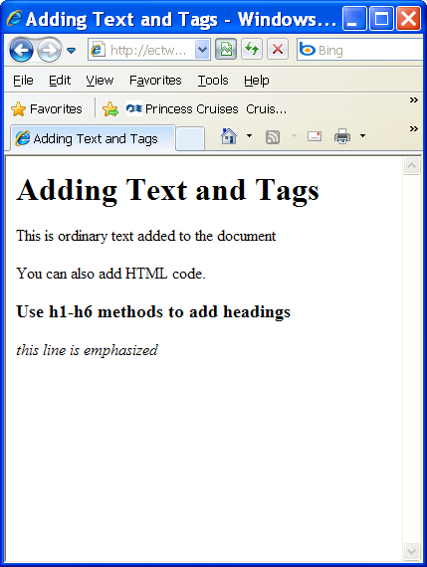 | Basics/AddingTags.php  <?php  include "SuperHTMLDef.php";  $s = new SuperHTML("Adding Text and Tags");  $s->buildTop();  $s->addText("<p>This is ordinary text added to the document</p>");  $s->addText("<div>You can also add HTML code.</div>");  $s->h3("Use h1-h6 methods to add headings");  $s->addText("<div>");  $s->tag("em", "this line is emphasized");  $s->addText("</div>");  $s->buildBottom();  print $s->getPage();  ?>

Creating Lists
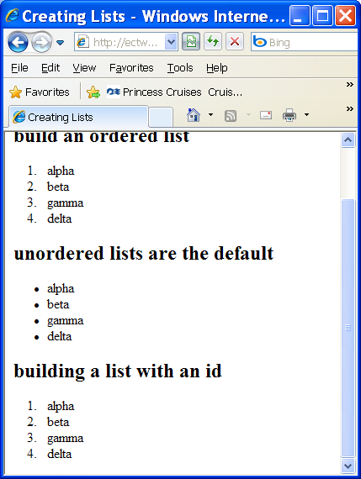 | Basics/Lists.php  <?php  include "SuperHTMLDef.php";  $s = new SuperHTML("Creating Lists");  $s->buildTop();  $myArray =array("alpha", "beta", "gamma", "delta");  $s->h2("build an ordered list");  $s->buildList($myArray, "ol");  $s->h2("unordered lists are the default");  $s->buildList(array("alpha", "beta", "gamma", "delta"));  $s->h2("building a list with an id");  $s->buildList($myArray, "ol id = 'fancy'");  $s->buildBottom();  print $s->getPage();  ?>

Making Tables
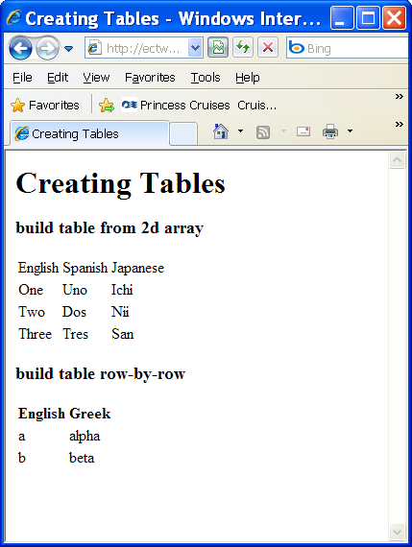 | Basics/Tables.php  <?php  include "SuperHTMLDef.php";  $s = new SuperHTML("Creating Tables");  $s->buildTop();  $s->h3("build table from 2d array");  $myArray = array(  array("English", "Spanish", "Japanese"),  array("One", "Uno", "Ichi"),  array("Two", "Dos", "Nii"),  array("Three", "Tres", "San")  );  $s->buildTable($myArray);  $s->h3("build table row-by-row");  $s->startTable();  $s->tRow(array("English", "Greek"), "th");  $s->tRow(array("a", "alpha"));  $s->tRow(array("b", "beta"));  $s->endTable();  $s->buildBottom();  print $s->getPage();  ?>

Creating Forms
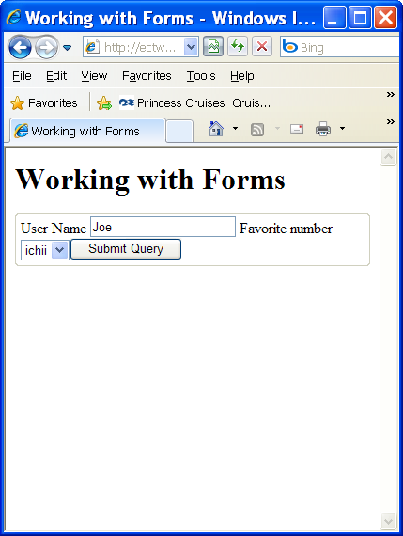 | Basics/Forms.php  <?php  include "SuperHTMLDef.php";  $s = new SuperHTML("Working with Forms");  $s->buildTop();  $s->startForm();  $s->label("User Name");  $s->textbox("userName", "Joe");  $numbers = array(  "1"=>"ichii",  "2"=>"nii",  "3"=>"san",  "4"=>"shi"  );  $s->label("Favorite number");  $s->select("favNumber", $numbers);  $s->submit();  $s->endForm();  print $s->formResults();  $s->buildBottom();  print $s->getPage();  ?>
Inheritance
PHP class definitions can optionally inherit from a parent class definition by using the extends clause. The syntax is:

class Child extends Parent {
<definition body>
}

The effect of inheritance is that the child class (or subclass or derived class) has the following characteristics:
- Automatically has all the member variable declarations of the parent class (or superclass or base class)
- Automatically has all the same member functions as the parent, which (by default) will work the same way as those functions do in the parent

In addition, the child class can add on any desired variables or functions simply by including them in the class definition in the usual way.

Overriding Functions
Function definitions in child classes override definitions with the same name in parent classes. This just means that the overriding definition in the more specific class takes precedence and will be the one actually executed.

Public, Private, and Protected Members
Unless you specify otherwise, properties and methods of a class are public. That is to say, they may be accessed in three possible situations:

- From outside the class in which it is declared
- From within the class in which it is declared
- From within another class that implements the class in which it is declared

If you wish to limit the accessibility of the members of a class, you should use private or protected.

Private Members
By designating a member private, you limit its accessibility to the class in which it is declared. The private member cannot be referred to from classes that inherit the class in which it is declared and cannot be accessed from outside the class.

Making a member private is straightforward:

class MyClass {

private $colorOfSky = "blue";
$nameOfShip = "Java Star";

public function __construct($incomingValue) {
// Statements here run every time an instance of the class
// is created.
}

public function myPublicFunction ($my_input) {
return("I'm visible!");
}

private function myPrivateFunction ($my_input) {
global $my_global;
return($my_global *
$my_input *
my_function($this->my_member));
}

}

When that class is inherited by another class (using extends), myPublicFunction() will be visible, as will $nameOfShip. The extending class will not have any awareness of or access to myPrivateFunction, because it is declared private.

Protected Members
A protected property or method is accessible in the class in which it is declared, as well as in classes that extend that class. Protected members are not available outside of those two kinds of classes, however.

Here is a different version of MyClass:

class MyClass {

protected $colorOfSky = "blue";

$nameOfShip = "Java Star";

public function __construct($incomingValue) {
// Statements here run every time an instance
// of the class is created.
}

public function myPublicFunction ($my_input) {
return("I'm visible!");
}

protected function myProtectedFunction ($my_input) {
global $my_global;
return($my_global *
$my_input *
my_function($this->my_member));
}

}

If we had another class that extended MyClass, it would be able to see and use $colorOfSky and myProtectedFunction(), just as if they were public.

Interfaces
In large object-oriented projects, there is some advantage to be realized in having standard names for methods that do certain work. For example, if many classes in a software application needed to be able to send e-mail messages, it would be desirable if they all did the job with methods of the same name and had the same number and type of arguments.

interface Mail {
public function sendMail();
}

Then, if another class implemented that interface, like this:

class Report implements Mail {
// Definition goes here
}

it would be required to have a method called sendMail. It's an aid to standardization.

Constants
A constant is somewhat like a variable, in that it holds a value but is really more like a function because a constant is immutable. Once you declare a constant, it does not change. Declaring one is easy, as is done in this version of MyClass:

class MyClass {

const requiredMargin = 1.3;

function __construct($incomingValue) {
// Statements here run every time an instance of the class
// is created.
}

}

In that class, requiredMargin is a constant. It is declared with the keyword const, and under no circumstances can it be changed to anything other than 1.3. Note that the constant's name does not have a leading $, as variable names do.

Abstract Classes
An abstract class is one that cannot be instantiated, only inherited. You declare an abstract class with the keyword abstract, like this:

abstract class MyAbstractClass {

abstract function myAbstractFunction() {
}

}

Note that function definitions inside an abstract class must also be preceded by the keyword abstract. It is not legal to have abstract function definitions inside a nonabstract class.

